Hermes Payment Processor

The primary goal of Hermes is to reduce friction between the user by providing a smooth user experience for the end users and the merchants while providing a decentralized platform with little (< $0.01) to no fees.

How will Hermes accomplish this? There are two primary products that Hermes will have the wallet platform and the payment processor.

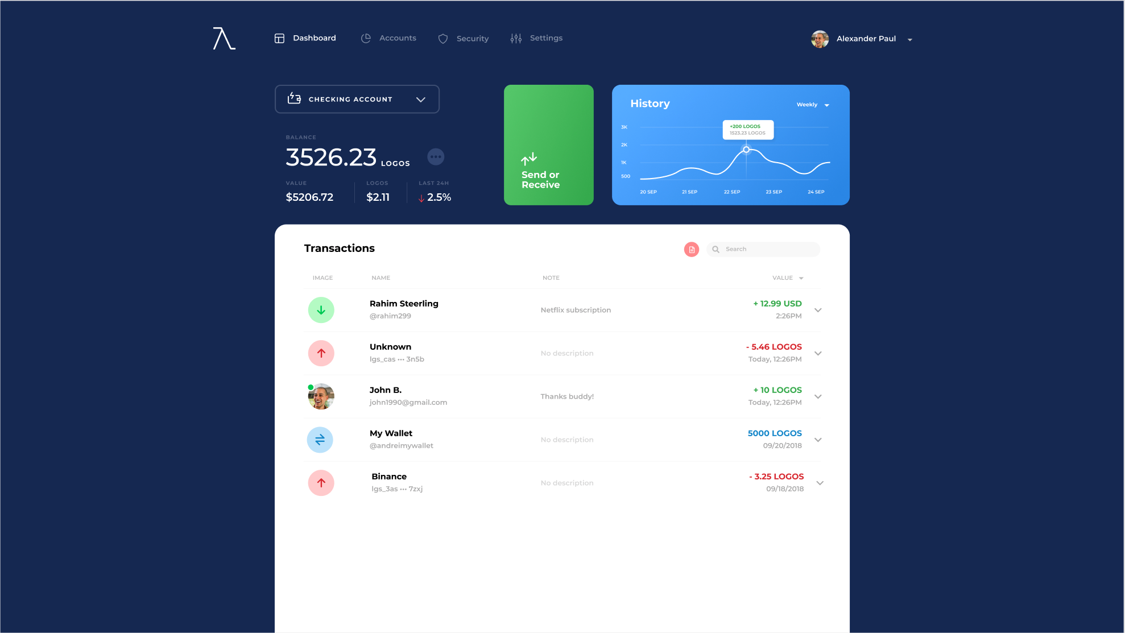

Hermes Wallet Platform

The first is the **Hermes Wallet Platform.** The wallet is similar to what users would expect when using PayPal / Venmo. The wallet provides insight into all the transactions you send and receive. There are no additional fees when using the Hermes Wallet besides the standard network fee which should range between $0.00 - $0.01 per transaction. The current Mock-up shows the system with how it works using Logos but there are plans to integrate stablecoin support once available. There are two types of wallets in the Hermes wallet, *Checking Account* and *Savings Accounts / Vaults*.

The *Checking Account* is a hot wallet can only make transactions using key splitting of 3 keys. One of the keys is encrypted by the user’s data such as password and other user supplied data, the second key is stored on a Hermes HSM, and the final key is stored in cold storage by Hermes. This allows us the capability of sending transactions on behalf of the user immediately when the user approves the transactions. In the case where the user loses his/her password or access to their account Hermes can recover the users funds using the key stored in cold storage.

The *Savings Accounts / Vaults* are an advanced feature for only the true crypto diehards. These type of wallets are in the full control of the user and Hermes has no access to user funds. If the user loses their password to Hermes and doesn’t have the seed stored in a secure place then the user will have lost access to his or her funds. This is allows crypto enthusiast to use Hermes without us having any control over their actions.

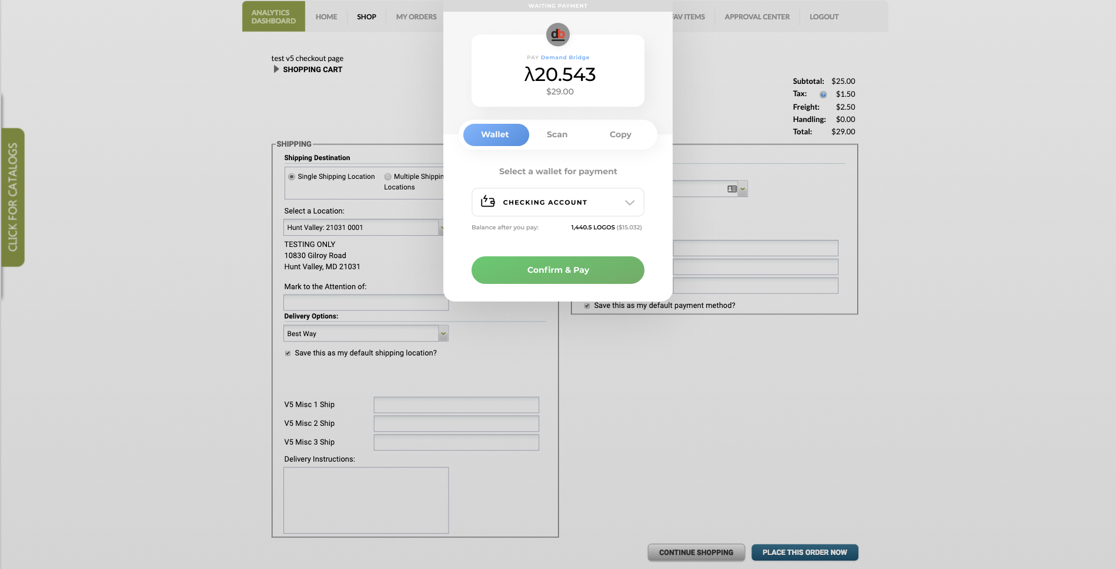

Payment Processor

The second product is the **Hermes Payment Processor** the payment processor will allow merchants to integrate Logos and Logos Stablecoin payments into their applications. The goal of the payment processor is to mirror the functionality of payments processors such as Stripe. The processors provides APIs, Webhooks, and easy web application integration using your generated api-token.